Week 5 handout: prepositions & conditionals
Prepositions
Fill in the correct preposition in each blank. Sometimes there may be more than one possibility. In those cases, just choose the one that you find to be the most logical choice.
1. _________________ 10 o’clock PM, _________________ the latest, I will have handed in my essay.
2. _________________ one year’s time, I will be receiving my diploma!
3. I arrived so early that the main doors weren’t even open yet. So I just stood there _________________ the building until I was allowed in. _________________ a moment I considered walking _________________ the building to the back door. But _________________ course, I knew it would be locked as well.
4. I’m so bad _________________ organizing my day. I hardly even wake up _________________ time to eat a proper breakfast.
But then again, I have noticed that my 9:00 lecture never seems to start _________________ time.
My professor is usually five minutes late. I hear she’s been doing this _________________ many years, but she just gets away with it.
I probably arrive _________________ school even before she does!
Well maybe not, but I’m certainly _________________ the classroom, _________________ my desk, first. _________________ least, most _________________ the time.

Conditional sentences
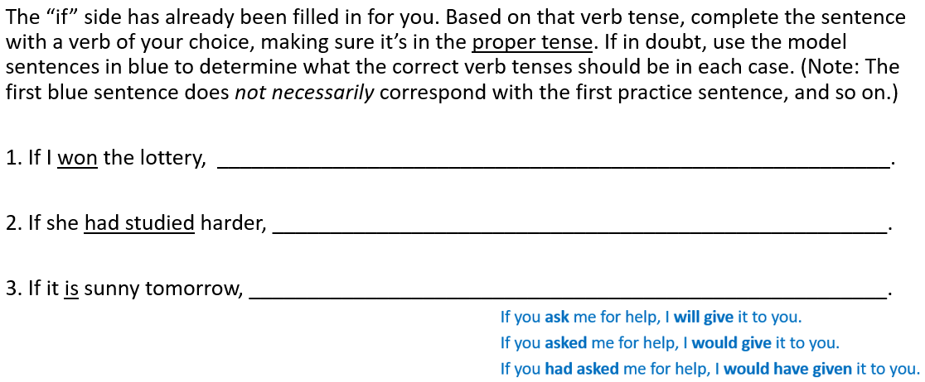

Conditional sentences (continued)
